ICT283 (not assessed but should be attempted)

Objectives:
To learn
- How to read C++ code
- Work with C strings – null terminated arrays of char.
- Do code maintenance.
- Do testing.

It is very important not to fall behind with these exercises.

You should note that even though an exercise is not assessed, not attempting the exercise would make it very difficult for you to understand subsequent material.

If you want to work on you own computer, install Graphviz first, then install Doxygen.

Exercise

To do this lab, you must have completed all previous work. Revision exercise must be submitted.

If you have skipped any exercise in any of the previous labs, please go back and complete.

When working through the exercises in this lab, start at exercise 1 and work through each exercise systematically in sequence.

Do not start coding until you have worked out exactly what is required. Do this requirement extraction carefully, ideally on paper or in a separate document. Take note of the advice given about Requirements in Topic 1 notes.

Draw a UML diagram illustrating how the classes are connected and being used. Please read all the sub exercises (sub tasks) below first to work out what is needed and then plan the best way to tackle each of the sub tasks listed. You may need to read the specifications more than once to understand what is really needed. Make sure you document all code in .h files using doxygen style comments.

Think about the test data you will use to demonstrate that your program works. Create the test table. Use the table format from the revision exercise. You can assume that the input data file contains data in the correct format. This means that you must create the data file correctly.

For this lab, C (not C++) style strings are used. See the textbook chapter on Arrays and Strings (sub-section C-Strings). C-strings are arrays of char terminated by the null character. C++ strings are objects, similar to Java string.

C-strings routines are fast as C-strings are not object-oriented. But such strings need to be handled carefully as there is no protection if you exceed array bounds. You may want to take a look at this site http://www.cplusplus.com/. The library reference http://www.cplusplus.com/reference/ shows what is available in the C library. See cstring (string.h).

In C++ code you would normally have the pre-processor #include <cstring>. You will find an explanation of each of the C-string routine along with an example showing to use of the routine. Lec-08.ppt in Topic03 also has some brief descriptions with examples of how to use char pointers (char *). In the table of string functions, str, str1, str2, src, dest, needle, haystack are of type char *. Everything that has been covered with pointers applies. So, in each of the string functions every char * parameter points to the start of char arrays. An empty C string will have the null byte as the first element of the char array. A non-empty C string will have char array terminated by the null byte. You would notice this in the constructor of the Course class – a null byte is put in as the first element of the name array (of char). Please go through Lec-07.ppt to see how arrays are used with pointers. The slide on Input Testing in Lec-07.ppt is when you are running the program on the command line – the way you would have run your program in your first programming unit ict159.

Codeblocks compiler settings are shown at the end of this lab sheet. Use the version from LMS.

Do not use the object-oriented string (std::string) for the exercises listed below. We will use std::string later.

For this exercise use underscores to join long names together so that they are actually one string. This is just for convenience to make it easy to deal with the strings for now.

You will need the UML for the registration exercise from Lab 2. Look at the requirements of each exercise below and update the UML from Lab 2 to cater for the requirements of this Lab 3. Changes to code indicated below will occur once you have the new UML and the new UML will serve as a plan for what is to be changed.

- Use Registration-code from Lab 2, a copy is provided with topic 3 practical.
Rename the Course class to Unit as it will be used to represent a unit at Murdoch. Change the file names (.h and .cpp) as well to reflect the class names. Registration will now contain the data structure array of Unit objects. Note the project in your IDE would need to now use the new file names. Modify the Unit class so that it has unit name, unit id and credits. Section name is not used. The output operators use the new attributes to display. Provide appropriate set and get methods for the Unit class. Update the doxygen comments in unit.h.
- Create a new class call Result. Result will contain a unit (one Unit object, from exc. 1 above) and the mark (one floating point number) obtained for that unit. Provide appropriate set and get methods for Result. A set method will only set one attribute and a get method will get just one attribute. Think about how the class will be used. The registration class will be modified to have an array of Results instead of an array of Units.
Modify the data file to cater for marks. The output operator for Result should output the unit information and the mark. Note that Result can’t access unit information directly as that information is stored as private in the Unit class. The output for the Registration object in the output data file will contain the Student ID, Semester, unit information and marks for each unit. Note that the Registration object can’t access the data members of other objects that Registration contains. You will need the UML diagram to see how Registration can do what is required of it without making data members of its contained classes public.
Examine the original client program (main.cpp). A Course object is created after the Registration object R is output. You will need to change to a Unit object with the correct parameter for the constructor.

- Create an input data file with unit information relevant to Murdoch units. See the sample output at the end of this document. Modify the main program so that the new data file is used with the correct unit information. Test your program to make sure it works as before.

When the program is run, the output of the Registration object R should be in a similar format as the output in the previous exercise except it will have more relevant information. A sample run is given below.

- Run doxygen and examine the output to see that your initial design (using staruml) matches the design as shown in doxygen.

- Examine the client program (main.cpp). What changes did you have to make to this file other than those asked for above?

- You would have to submit the revision exercise (exercise 1 of lab 2) to get access to the materials in this topic. Review what you submitted. Is there any routine that does more than one thing; for example, any routine that does both calculation and output within the same routine? Any routine whose code takes up longer than one screen? Are global variables used? Are I/O routines separated into .h interface and .c implementation files? Can you see duplicated functionality, different routines for calculating different currencies or one generic routine that works out the currency depending on the numeric values that have been sent? If there are calculation routines that depend on the currency, can you make these routines independent of currency – the routine does not need to know the currency.

- Is it possible to have a coin change program that can handle any future coin denomination without changes to the source code? In other words, once a program executable is created, the program can handle any future coin denomination without access to the source code. Your program must not ask the user to enter data. Data input is from the specified file.

Sample Run for the registration exercise:

Student ID: 12345678
Semester: 1
Unit ID: ICT283
Unit Name: Data_Structures_And_Abstractions
Credits: 3
Marks: 90

Unit ID: ICT289
Unit Name: Computer_Graphics
Credits: 3
Marks: 97

Number of Units = 2
Total Credits = 6

Codeblocks Compiler Settings (choose C++11)
Do not choose any optimisations.
Turn on all warnings. The compiler is your friend as it will help you detect some potential problems with your code.

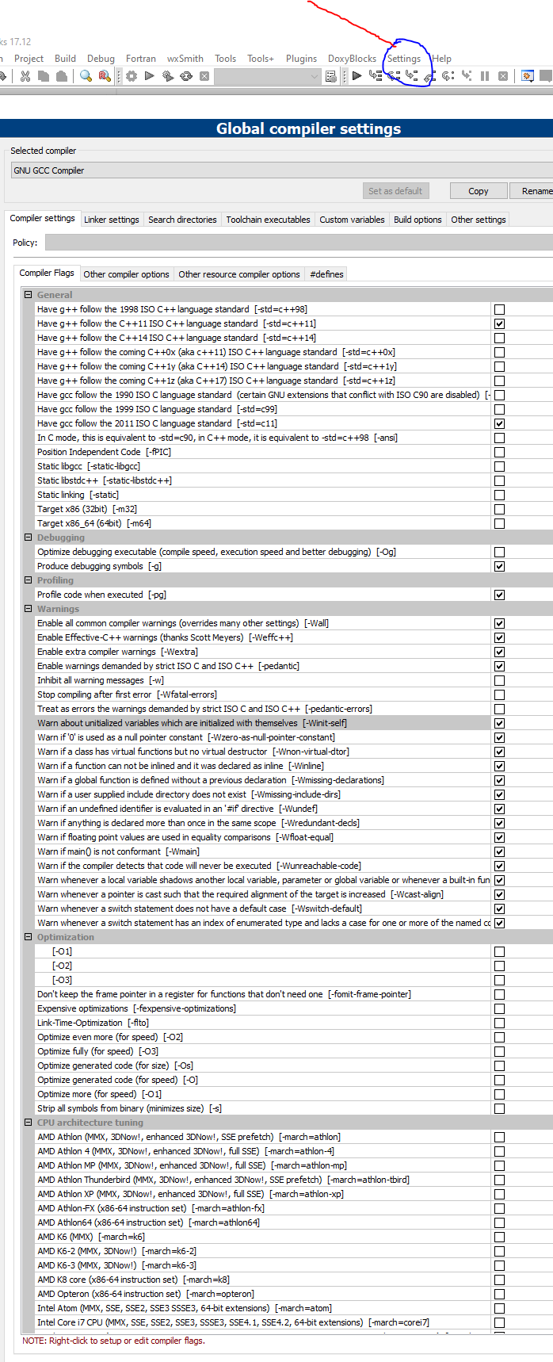
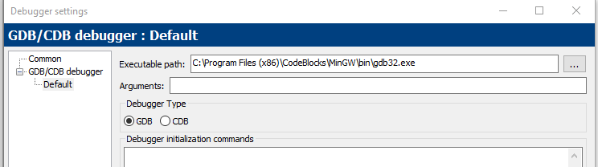

Now that Unit is in Result, it would not make sense for Registration to have array of units. So Registration will have an array of results.

